System and Software Architecture Description (SSAD)

LINGGGO

Team 3

Chicheng Ren – Software Architect
Dahai Li – Quality Focal Point
Dashun Wen – Life Cycle Planner
Kraingkrai Bumroungruksa – Prototyper
Siming Ye – Feasibility Analyst
Shiqi Wei – Operational Concepts Engineer
Yiting Xiao – Project Manager

11/30/15

Version History
Date | Author | Version | Changes made | Rationale
10/17/15 | KB | 1.0 | - Documented sections 1-2 | - Initial draft for use with Instructional ICM-Sw v1.0
10/19/15 | DL | 1.1 | - Updated Users to Language Learners | - Change to consistent stakeholder names
11/30/15 | CR | 1.2 | - All document sections | - Final draft

Table of Contents
System and Software Architecture Description (SSAD) i
Version History ii
Table of Contents iii
Table of Tables iv
Table of Figures vi
1. Introduction 1
1.1 Purpose of the SSAD 1
1.2 Status of the SSAD 1
2. System Analysis 2
2.1 System Analysis Overview 2
2.2 System Analysis Rationale 9
3. Technology-Independent Model 10
3.1 Design Overview 10
3.2 Design Rationale 18
4. Technology-Specific System Design 19
4.1 Design Overview 19
4.2 Design Rationale 27
5. Architectural Styles, Patterns and Frameworks 29

Table of Tables
Table 1: Actors Summary 2
Table 2: Artifacts and Information Summary 3
Table 3: Process Description 4
Table 4: Typical Course of Action – Login Successfully 4
Table 5 : Process Desscription 5
Table 6 : Typical Course of Action – Logout Successfully 5
Table 7 : Process Description 5
Table 8 : Typical Course of Action – Signup Successfully 5
Table 9 : Alternate Course of Action – Username/ email Already Exist 6
Table 10 : Alternate Course of Action – Not Imputting All Required Fields 6
Table 11 : Process Description 7
Table 12 : Typical Course of Action – Profile Update Successfully 7
Table 13 : Alternate Course of Action – Not Inputting All Required Fields 7
Table 14 : Process Description 7
Table 15 : Typical Course of Action – Match Successfully 8
Table 16 : Alternate Course of Action – No Data Found 8
Table 17 : Process Description 8
Table 18 : Typical Course of Action – Send Message Successfully 9
Table 19 : Alternate Course of Action – Missing Required Field 9
Table 20 : Hardware Component Class Description (TI) 10
Table 21: Software Component Class Description (TI) 11
Table 22 : Profile Management Class Description (TI) 13
Table 23 : Match System Class Diagram (TI) 15
Table 24 : Message System Class Description (TI) 15
Table 25 : Hardware Component Description (TS) 19
Table 26 : Software Component Description (TS) 20
Table 27 : Profile Management Class Description (TS) 23
Table 28 : Match Class Description (TS) 24
Table 29 : Message Class Description (TS) 25
Table 30 : Architectural Styles, Patterns and Frameworks 29

Table of Figures
Figure 1: System Context Diagram 2
Figure 2: Artifacts and Information Diagram 3
Figure 3: Process Diagram 4
Figure 4 : Hardware Class Diagram (TI) 10
Figure 5 : Software Component Class Diagram (TI) 11
Figure 6 : Deployment Diagram (TI) 12
Figure 7 : Profile Management Class Diagram (TI) 13
Figure 8 : Match System Class Diagram (TI) 14
Figure 9 : Message System Class Diagram (TI) 15
Figure 10 : Profile Management Sequence Diagram (TI) 16
Figure 11 : Match Sequence Diagram (TI) 17
Figure 12 : Send Message Sequence Diagram (TI) 17
Figure 13 : Receive Message Sequence Diagram (TI) 18
Figure 14 : Hardware Component Diagram (TS) 19
Figure 15 : Software Component Diagram (TS) 20
Figure 16 : Deployment Diagram (TS) 21
Figure 17 : Profile Management Class Diagram (TS) 22
Figure 18 : Match Class Diagram (TS) 24
Figure 19 : Message Class Diagram (TS) 25
Figure 20 : Profile Management Sequence Diagram (TS) 26
Figure 21 : Match Sequence Diagram (TS) 26
Figure 22 : Send Message Sequence Diagram (TS) 27
Figure 23 : Receive Message Sequence Diagram (TS) 27

Introduction

Purpose of the SSAD
The purpose of this document is to provide the whole picture and a deep understanding of LINGGGO’s behavior and functionalities. It shows all of the actors interacting with the system. Also, all important system artifacts have been shown in detail.

Status of the SSAD
The current version contains the system’s behavior, actor, and functionalities.

System Analysis

System Analysis Overview
The main purpose of LINGGGO is to enable Language Learners who want to learn other languages by practicing with native speakers of that particular language. The system matches language learners according to their language preferences. For example, English speakers who want to learn Chinese language will be matched to Chinese speakers who want to learn English. Then, the users(language learners) can send messages to each other and decide which communication tool is comfortable with them(e.g. Skype).

System Context
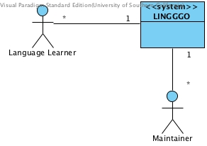
Figure 1: System Context Diagram
Table 1: Actors Summary
Actor | Description | Responsibilities
Language Learner | Language learners use the system to find other languages learners to learn/teach new languages | - Create profile and set language preferences  - Contact other language learners that they are interested

Artifacts & Information
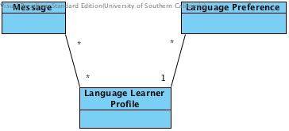
Figure 2: Artifacts and Information Diagram
Table 2: Artifacts and Information Summary
Artifact | Purpose
Language Learner Profile | Contains all language learner registration information including sex, location, and native language
Language Preference | Contains Language Learners' desire to learn languages including priority
Message | Contains all messages of Language Learner's communication

Behavior
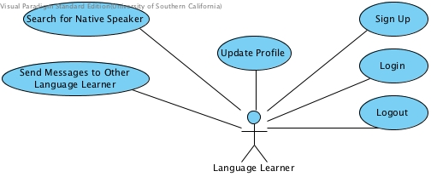
Figure 3: Process Diagram

Capability

Process Login
Table 3: Process Description
Identifier | Login
Purpose | To log language Learner into the system and get their profile information
Requirements | Account is already created
Development Risks | Security in user credentials
Pre-conditions | Language Learner is at the login page
Post-conditions | Language Learner is logged into the system and can see their profile information

Table 4: Typical Course of Action – Login Successfully
Seq# | Actor’s Action | System’s Response
1 | Language Learner inputs their username and password
2 | Language Learner clicks login button
3 |  | Check whether username and password match the record in the database
4 |  | Return profile information and show login successful message
2.1.3.1.2 Process Logout
Table 5 : Process Desscription
Identifier | Logout
Purpose | To log Language Learner out from the system and clear their session data
Requirements | Authentication & Authorization
Development Risks | If the system does not clear the session data, other people can use that computer to access Language Learner information.
Pre-conditions | Language Learner has already logged in
Post-conditions | Clear session, bring user back to home page, and show message logout successfully
Table 6 : Typical Course of Action – Logout Successfully
Seq# | Actor’s Action | System’s Response
1 | Language Learner clicks on logout button
2 |  | System clears Language Learner session from the server
3 |  | Return Language Learner to home page and show logout successful message
2.1.3.2 Capability Profile Management
2.1.3.2.1 Process Profile Registration
Table 7 : Process Description
Identifier | Signup
Purpose | To create Language Learner account in the system
Requirements | None
Development Risks | None
Pre-conditions | Language Learner is at the signup page
Post-conditions | Language Learner’s account is created with their input information and the account is logged into the system automatically
Table 8 : Typical Course of Action – Signup Successfully
Seq# | Actor’s Action | System’s Response
1 | Language Learner inputs all required fields
2 | Language Learner clicks submit button
3 |  | System checks whether username/email already exist in the system or not
4 |  | System checks whether Language Learner inputs all required fields
5 |  | System creates account for Language Learner based on their inputs
6 |  | System logs Language Learner into the system
7 |  | Return Language Learner to home page and show signup successfully message
Table 9 : Alternate Course of Action – Username/ email Already Exist
Seq# | Actor’s Action | System’s Response
1 | Language Learner inputs all required fields
2 | Language Learner clicks submit button
3 |  | System checks whether username/email already exist in the system or not
4 |  | System shows message username/email is already existed
Table 10 : Alternate Course of Action – Not Imputting All Required Fields
Seq# | Actor’s Action | System’s Response
1 | Language Learner inputs some of required fields
2 | Language Learner clicks submit button
3 |  | System checks whether username/email already exist in the system or not
4 |  | System checks whether Language Learner inputs all required fields
5 |  | System shows message “Please input all required fields”
2.1.3.2.2 Process Profile Update
Table 11 : Process Description
Identifier | Update Profile
Purpose | To update profile information
Requirements | Already have account in the system
Development Risks | Security
Pre-conditions | Language Learner is at the profile setting page
Post-conditions | Language Learner’s account is updated with their new information
Table 12 : Typical Course of Action – Profile Update Successfully
Seq# | Actor’s Action | System’s Response
1 | Language Learner inputs all required fields
2 | Language Learner clicks submit button
3 |  | System checks whether Language Learner inputs all required fields
4 |  | System updates Language Learner information
5 |  | Show update successful message
Table 13 : Alternate Course of Action – Not Inputting All Required Fields
Seq# | Actor’s Action | System’s Response
1 | Language Learner inputs some required fields
2 | Language Learner clicks submit button
3 |  | System checks whether Language Learner inputs all required fields
4 |  | System shows message “Please input all required fields”
2.1.3.3 Capability Matching Language Learners
2.1.3.3.1 Process Match Language Learners
Table 14 : Process Description
Identifier | Search for Native Speaker
Purpose | To find a native speaker of the language that Language Learners want to learn
Requirements | Authentication & Authorization
Development Risks | None
Pre-conditions | - Language Learner has already logged in  - The language preference has been already set  - Language Learner is at the matching page
Post-conditions | Return a list of Language Learners who are native speakers of the desired language. In case of no matching Language Learners, return no data found.
Table 15 : Typical Course of Action – Match Successfully
Seq# | Actor’s Action | System’s Response
1 | Language Learner chooses desired to learn language
2 | Language Learner clicks match button
3 |  | System checks language preferences for each language learner in the database to find the matching
4 |  | Show a list of Language Learners who are native speakers of the desired language
Table 16 : Alternate Course of Action – No Data Found
Seq# | Actor’s Action | System’s Response
1 | Language Learner chooses desired to learn language
2 | Language Learner clicks match button
3 |  | System checks language preferences for each language learner in the database to find the matching
4 |  | Show message no matching found
2.1.3.4 Capability Messaging
2.1.3.4.1 Process Send Message to Language Learners
Table 17 : Process Description
Identifier | Send messages to other language learners
Purpose | To send message to other language learner to have a conversation
Requirements | Authentication & Authorization
Development Risks | None
Pre-conditions | Language Learner has already logged in
Post-conditions | Return a list of Language Learners who are native speakers of the desired language. In case of no matching Language Learners, return no data found.
Table 18 : Typical Course of Action – Send Message Successfully
Seq# | Actor’s Action | System’s Response
1 | Go to the profile of other language learner
2 | Click send message button
3 |  | System brings Language Learner to send message page
4 | Type message content
5 | Click send button
6 |  | System check that message is not empty
7 |  | System saves message into database and show send successful message
Table 19 : Alternate Course of Action – Missing Required Field
Seq# | Actor’s Action | System’s Response
1 | Go to the profile of other language learner
2 | Click send message button
3 |  | System brings Language Learner to send message page
4 | Click send button
5 |  | System check that message is not empty
6 |  | System shows message “Please fill in the content”

Modes of Operation

The system will operate in only one mode, so nothing further need be said of modes of operation.

System Analysis Rationale

There is 1 type of actors in the system: Language Learner and Maintainer.
- Language Learner: A user who wants to learn new language.

Technology-Independent Model

Design Overview

System Structure
Figure 4 : Hardware Class Diagram (TI)
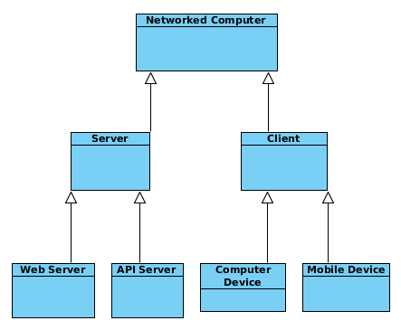
Table 20 : Hardware Component Class Description (TI)
Hardware Component | Description
Networked Computer | The computer/mobile device connected to the Internet
Server | Servers where we deploy the LINGGGO system
Client | Client devices that are able to connect to the LINGGO server
Web Server | The server which serves all the front-end element for the clients
API Server | The server which provides the access to back-end APIs
Computer Devices | Client’s devices running desktop OS, such as: Windows and etc.
Mobile Devices | Client’s devices running mobile OS, such as: iOS and etc.

Figure 5 : Software Component Class Diagram (TI)
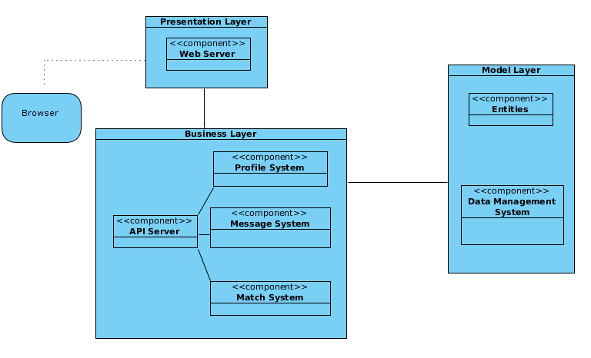
Table 21: Software Component Class Description (TI)
Software Component | Description
Presentation Layer | This layer provides the access to all the resources of the front-end elements in the LINGGGO system, including HTML pages, images, CSS and javascript. This client (Language Learner) directly interacts with this layers.
Business Layer | This layer provides the business logic of the LINGGGO system. It defines the APIs which can be later called to access the resources in the back-end system (back-end server and database). This layer is not directly accessible to the client themselves but should be called by the presentation layer.
Model Layer | This layer provides the storage and management of different data in the LINGGGO system, in the form of tables. It also gives the APIs so that the business layer can access the data in the data management system.

Figure 6 : Deployment Diagram (TI)
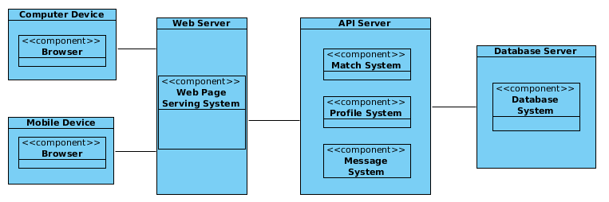

Design Classes
*: Since we’re using REST system architecture, each entity has its own class method to modify its data. It serves both the role of Entity and Controller.

Profile Management
Figure 7 : Profile Management Class Diagram (TI)
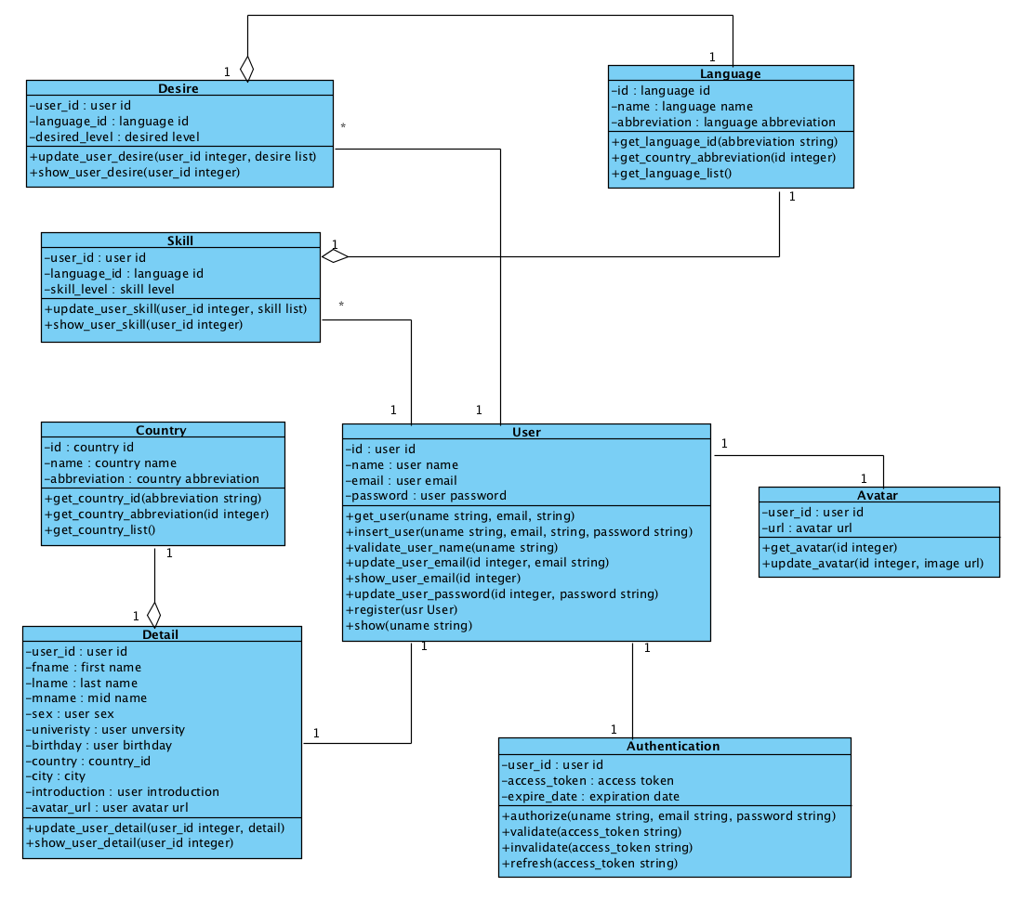
Table 22 : Profile Management Class Description (TI)
Class | Type | Description
Desire | Entity, Controller | It shows user’s desired language. One user can have multiple desired language.
Skill | Entity, Controller | It shows user’s skilled language. One user can have multiple skilled language
User | Entity, Controller | It stores user’s authentication information including user id, user name, user email and password.
Detail | Entity, Controller | It stores user’s detail information.
Authentication | Entity, Controller | It stores user’s authentication for logging into the system
Avatar | Entity, Controller | It stores user’s avatar information.
Language | Entity, Controller | It stores all the languages supported in the system, including: language id, name and abbreviation.
Country | Entity, Controller | It stores all the countries supported in the system, including: country id, name and abbreviation

Match System
Figure 8 : Match System Class Diagram (TI)
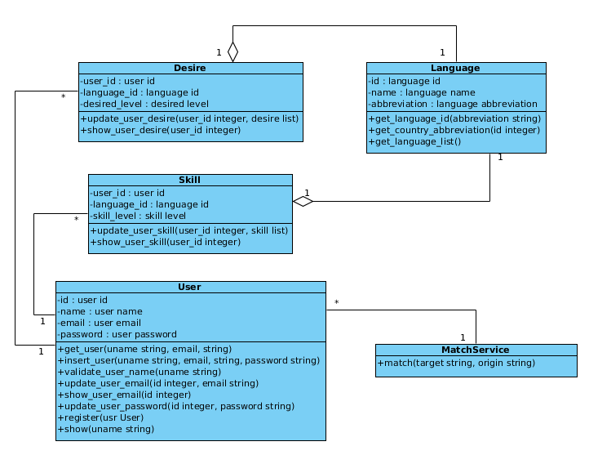
Table 23 : Match System Class Diagram (TI)
Class | Type | Description
User | Entity, Controller | It stores user’s authentication information including user id, user name, user email and password.
Desire | Entity, Controller | It shows user’s desired language. One user can have multiple desired language.
Skill | Entity, Controller | It shows user’s skilled language. One user can have multiple skilled language
Language | Entity, Controller | It stores all the languages supported in the system, including: language id, name and abbreviation.
MatchService | Controller | It retrieves the data from database and generated the matched user for a API call.

Message System
Figure 9 : Message System Class Diagram (TI)
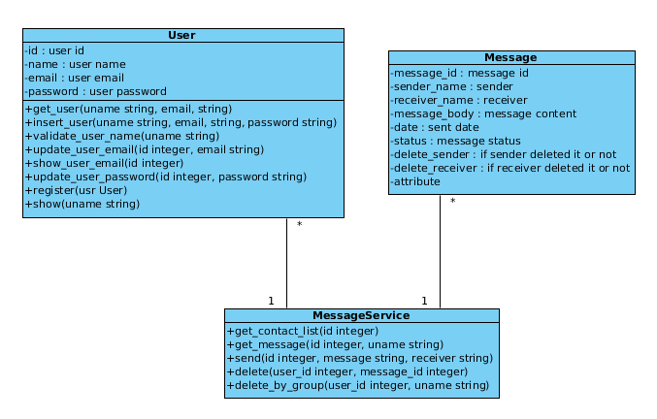
Table 24 : Message System Class Description (TI)
Class | Type | Description
User | Entity, Controller | It stores user’s authentication information including user id, user name, user email and password.
Message | Entity | It keeps the record of one message.
MessageService | Controller | It controls the logic for a language

Process Realization
In this section, we will show 3 sequence diagrams which accords with our three main functionalities in our system.
The language learners use the profile management page to manage and update their profiles.
Figure 10 : Profile Management Sequence Diagram (TI)
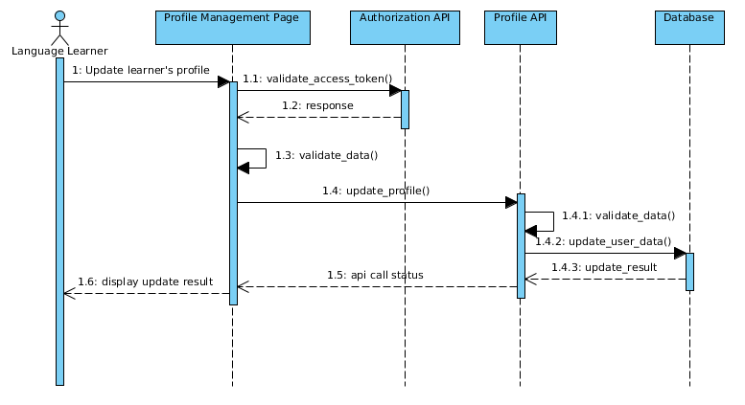
The language learner uses the match page to match others people with the corresponding desire.

Figure 11 : Match Sequence Diagram (TI)
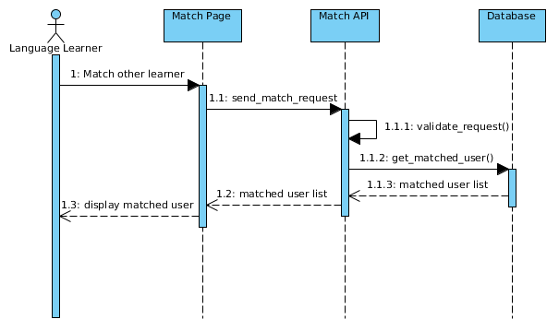
The language learner uses the message interface to send the message to one other language learner.
Figure 12 : Send Message Sequence Diagram (TI)
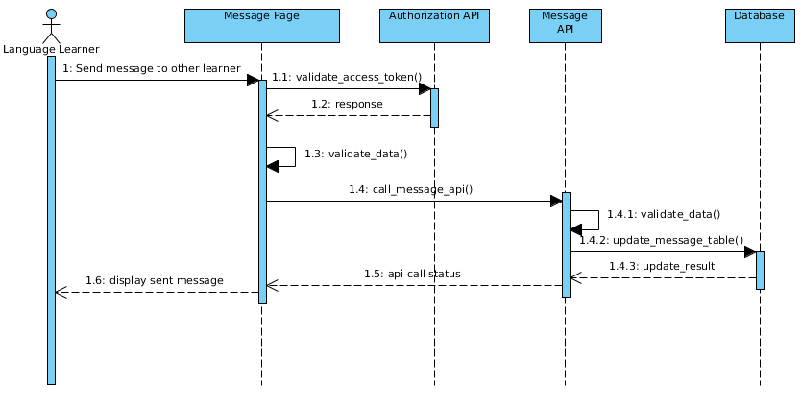
The language learner uses the message interface to receive the message to one other language learner.
Figure 13 : Receive Message Sequence Diagram (TI)
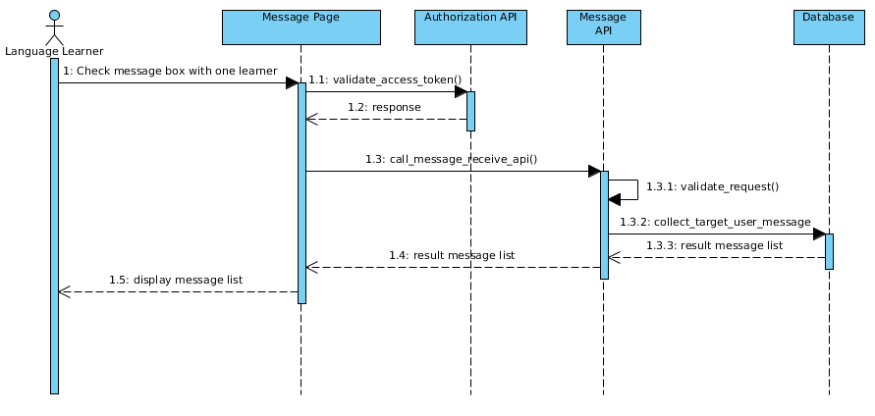

Design Rationale
As the LINGGGO project is meanly web-based application and we want to reserve the potential to later extend its capabilities for other platform development. We adopt the idea of REST and we mainly use 3-tier architecture in our system. The presentation layer is done by the web server and client browser and this tier is only in charge of maintaining communication between the client and the server and little business logic is implemented here to keep the client simple (but heavy user interface setup). The second and third tier are currently combined together and lay on the API server. The API server is responsible for processing client’s request and sending back corresponding result. This layer is only in charge of business logic and data management and it has nothing to do with how to present the data to the client. This kind of architecture has several advantages: a. This system architecture reduces the overhead between the client and server by eliminating unnecessary data transfer between the client and server as we avoid transferring duplicate HTML and other static resources b. This system architecture reduces the cohesion of the development process between the front-end and back-end development so that both parts of the team can focus on their own development environment as AJAX technology is platform-independent and REST system architecture determines the correct how to parse the AJAX data c. This system architecture can also be easily converted into distributed structure if we encounter a bottleneck on a single server which runs the entire API services.

Technology-Specific System Design

Design Overview

System Structure
Figure 14 : Hardware Component Diagram (TS)
Table 25 : Hardware Component Description (TS)
Hardware Component | Description
Networked Computer | The computer/mobile device connected to the Internet
Server | Servers where we deploy the LINGGGO system
Client | Client devices that are able to connect to the LINGGO server
Web Server | The server which serves all the front-end element for the clients
API Server | The server which provides the access to back-end APIs
Computer Devices | Client’s devices running desktop OS, such as: Windows and etc.
Mobile Devices | Client’s devices running mobile OS, such as: iOS and etc.
Figure 15 : Software Component Diagram (TS)
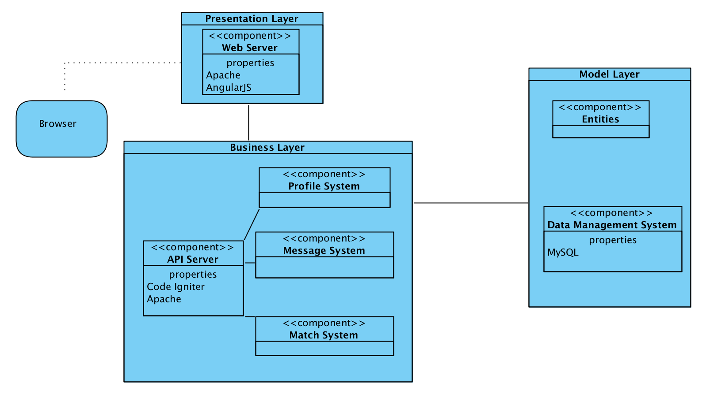
Table 26 : Software Component Description (TS)

Software Component | Description
Presentation Layer | This layer utilizes the Apache web server to provide the access to all the resources of the front-end elements in the LINGGGO system, including HTML pages, images, CSS and javascript. This client (Language Learner) directly interacts with this layers through different common web browser such as Chrome, Firefox, Safari, Internet Explorer and Opera.
Business Layer | This layer utilizes the Apache Server (with PHP mod) and PHP framework ‘Code Igniter’ to provide the business logic of the LINGGGO system. It defines the APIs which can be later called to access the resources in the back-end system (back-end server and database). This layer is not directly accessible to the client themselves but should be called by the presentation layer.
Model Layer | This layer utilizes the MySQL database to provide the storage and management of different data in the LINGGGO system, in the form of tables. It also gives the APIs so that the business layer can access the data in the data management system.
Figure 16 : Deployment Diagram (TS)
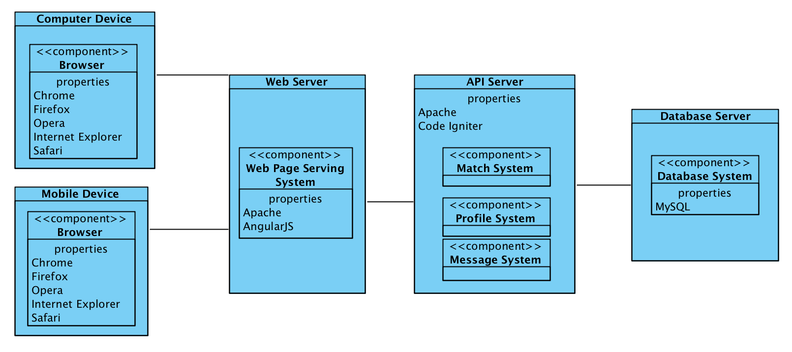

Design Classes
*: Since we’re using REST system architecture, each entity has its own class method to modify its data. It serves both the role of Entity and Controller.

Profile Management
Figure 17 : Profile Management Class Diagram (TS)
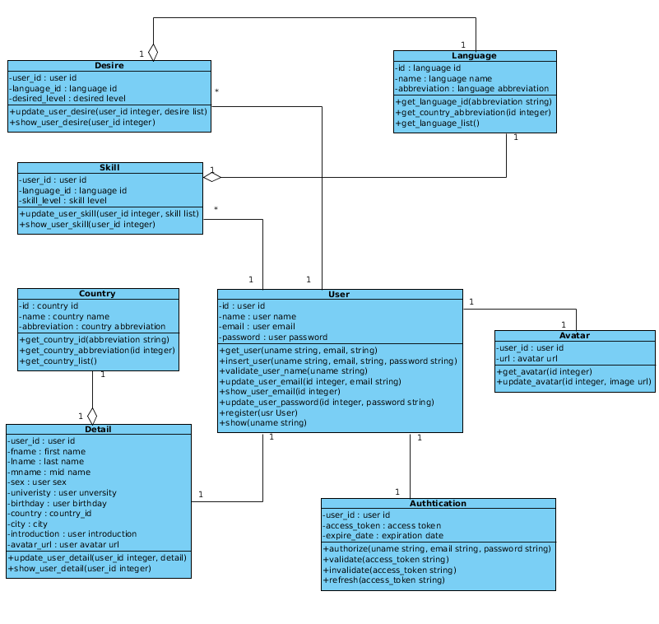

Table 27 : Profile Management Class Description (TS)
Class | Type | Description
Desire | Entity, Controller | It shows user’s desired language. One user can have multiple desired language.
Skill | Entity, Controller | It shows user’s skilled language. One user can have multiple skilled language
User | Entity, Controller | It stores user’s authentication information including user id, user name, user email and password.
Detail | Entity, Controller | It stores user’s detail information.
Authentication | Entity, Controller | It stores user’s authentication for logging into the system
Avatar | Entity, Controller | It stores user’s avatar information.
Language | Entity, Controller | It stores all the languages supported in the system, including: language id, name and abbreviation.
Country | Entity, Controller | It stores all the countries supported in the system, including: country id, name and abbreviation
Figure 18 : Match Class Diagram (TS)
Table 28 : Match Class Description (TS)

Class | Type | Description
User | Entity, Controller | It stores user’s authentication information including user id, user name, user email and password.
Desire | Entity, Controller | It shows user’s desired language. One user can have multiple desired language.
Skill | Entity, Controller | It shows user’s skilled language. One user can have multiple skilled language
Language | Entity, Controller | It stores all the languages supported in the system, including: language id, name and abbreviation.
MatchService | Controller | It retrieves the data from database and generated the matched user for a API call.
Figure 19 : Message Class Diagram (TS)
Table 29 : Message Class Description (TS)
Class | Type | Description
User | Entity, Controller | It stores user’s authentication information including user id, user name, user email and password.
Message | Entity | It keeps the record of one message.
MessageService | Controller | It controls the logic for a language

Process Realization
In this section, we will show 3 sequence diagrams which accords with our three main functionalities in our system.
The language learners use the profile management page to manage and update their profiles.
Figure 20 : Profile Management Sequence Diagram (TS)
The language learner uses the match page to match others people with the corresponding desire.
Figure 21 : Match Sequence Diagram (TS)
The language learner uses the message interface to send the message to one other language learner.
Figure 22 : Send Message Sequence Diagram (TS)
The language learner uses the message interface to receive the message to one other language learner.
Figure 23 : Receive Message Sequence Diagram (TS)

Design Rationale
As the LINGGGO project is meanly web-based application and we want to reserve the potential to later extend its capabilities for other platform development. We adopt the idea of REST and we mainly use 3-tier architecture in our system. The presentation layer is done by the web server and client browser and this tier is only in charge of maintaining communication between the client and the server and little business logic is implemented here to keep the client simple (but heavy user interface setup). The second and third tier are currently combined together and lay on the API server. The API server is responsible for processing client’s request and sending back corresponding result. This layer is only in charge of business logic and data management and it has nothing to do with how to present the data to the client. This kind of architecture has several advantages: a. This system architecture reduces the overhead between the client and server by eliminating unnecessary data transfer between the client and server as we avoid transferring duplicate HTML and other static resources b. This system architecture reduces the cohesion of the development process between the front-end and back-end development so that both parts of the team can focus on their own development environment as AJAX technology is platform-independent and REST system architecture determines the correct how to parse the AJAX data c. This system architecture can also be easily converted into distributed structure if we encounter a bottleneck on a single server which runs the entire API services.

Architectural Styles, Patterns and Frameworks
Table 30 : Architectural Styles, Patterns and Frameworks
Name | Description | Benefits, Costs, and Limitations
Code Igniter | PHP Model-View-Controller framework | Benefits:  - Easy connection to the MySQL database system  - Easy control of the traditional Model-View-Controller architecture setup  - Most of the back-end team members are familiar with PHP language and Code Igniter framework.  Cost:  - Free  Limitations:  - Performance Issue with PHP language
3-tier architecture | The system consists of three main parts: presentation, business and model layer | Benefits:  - Clear structure and responsibility of each layer  Cost:  - Free, no patent on this architecture  Limitations:  - Overhead between the layers. The layers have to send extra data during communication  - Tend to increase the complexity of the system architecture
AngularJS | Javascript framework | Benefits:  - Clear structure for the front-end system development  - Support for multiple platform  Cost:  - Free, open-sourced  Limitations:  - Some original libraries may perform as what the developer expect in the system, not reliable  - Learning curve  - Code-style problem from different programmers
REST | Representational state transfer (REST) is an software architecture style which defines the way to access a system. | Benefits:  - Distributed Resources System which has high scalability  - Platform-independent  - Reduce the overhead between the client and server  Cost:  - Free  Limitations:  - Error state detection  - Detailed documentation required  - Good API design

